Experiment No: 9 Date:

**Expert System**

**Aim:** To implement an Expert System for 4-wheeler Automobile maintenance.

# Theory:

# An expert system is a type of artificial intelligence (AI) system that emulates the decision-making ability of a human expert in a specific domain or field. It aims to solve complex problems by reasoning through knowledge, heuristics, and inference rules rather than by following predefined algorithms.

# 

# An expert system for automobile maintenance aims to provide diagnostic and troubleshooting assistance for common issues that car owners might encounter with their vehicles. This system utilizes a knowledge base of symptoms, potential causes, and recommended actions to guide users in identifying and addressing problems with their cars. Here's how we can implement it:

# Components of the Expert System:

# Knowledge Base: This comprises a database of symptoms, potential issues, and corresponding maintenance actions. It forms the foundation of the expert system and is used for diagnosis and recommendations.

# User Interface: The system interacts with users through a user-friendly interface where users can input symptoms and receive guidance on troubleshooting and maintenance.

# Inference Engine: The inference engine is responsible for processing user inputs, matching symptoms to potential issues, and generating recommendations based on predefined rules and logic.

# Characteristics of an Expert System :

# Human experts are perishable, but an expert system is permanent.

# It helps to distribute the expertise of a human.

# One expert system may contain knowledge from more than one human experts thus making the solutions more efficient.

# It decreases the cost of consulting an expert for various domains such as medical diagnosis.

# They use a knowledge base and inference engine.

# Expert systems can solve complex problems by deducing new facts through existing facts of knowledge, represented mostly as if-then rules rather than through conventional procedural code.

# Advantages :

# Low accessibility cost.

# Fast response.

# Not affected by emotions, unlike humans.

# Low error rate.

# Disadvantages :

# The expert system has no emotions.

# It is developed for a specific domain.

# It needs to be updated manually. It does not learn itself.

# Algorithm:

Algorithm ExpertSystem:

Input: Knowledge Base (KB), User Query (Q)

Output: System Response (R)

1. Acquire knowledge from experts or existing sources

2. Represent knowledge in a format understandable by the computer

3. Repeat until termination condition is met:

a. Receive user query Q

b. Apply inference engine to infer conclusions based on KB and Q

c. Provide explanations for the conclusions

d. Generate system response R

4. End Algorithm

**Example:**

# User Input:

# Symptoms: Strange engine noises, rough idling

# Diagnosis:

# Based on the symptoms provided, the system identifies potential issues such as engine problems and fuel system issues.

# Recommendations:

# Check engine oil level and quality

# Inspect belts and pulleys

# Clean or replace spark plugs

# Check air filter

# Program:

def ask_symptoms():

symptoms = []

print("Welcome to the Auto Maintenance Expert System!")

print("Please answer the following questions about your car's symptoms:")

print("1. Is the engine making strange noises? (yes/no)")

answer = input().lower()

if answer == "yes":

symptoms.append("Strange engine noises")

print(" - Is it a knocking sound or a squealing sound? (knocking/squealing)")

engine_noise_type = input().lower()

if engine_noise_type == "knocking":

symptoms.append("Knocking engine noise")

elif engine_noise_type == "squealing":

symptoms.append("Squealing engine noise")

print("2. Is the car experiencing rough idling? (yes/no)")

answer = input().lower()

if answer == "yes":

symptoms.append("Rough idling")

print(" - Is the idle RPM too high or too low? (high/low)")

idling_issue = input().lower()

if idling_issue == "high":

symptoms.append("High idle RPM")

elif idling_issue == "low":

symptoms.append("Low idle RPM")

print("3. Are you experiencing any issues with acceleration? (yes/no)")

answer = input().lower()

if answer == "yes":

symptoms.append("Acceleration issues")

print(" - Is the acceleration sluggish or jerky? (sluggish/jerky)")

acceleration_issue = input().lower()

if acceleration_issue == "sluggish":

symptoms.append("Sluggish acceleration")

elif acceleration_issue == "jerky":

symptoms.append("Jerky acceleration")

print("4. Is the car pulling to one side while driving? (yes/no)")

answer = input().lower()

if answer == "yes":

symptoms.append("Pulling to one side")

print(" - Is it pulling to the left or to the right? (left/right)")

pulling_side = input().lower()

if pulling_side == "left":

symptoms.append("Pulling to the left")

elif pulling_side == "right":

symptoms.append("Pulling to the right")

print("5. Is there smoke coming from the exhaust? (yes/no)")

answer = input().lower()

if answer == "yes":

symptoms.append("Smoke from exhaust")

print(" - What color is the smoke? (white/black/blue)")

smoke_color = input().lower()

if smoke_color == "white":

symptoms.append("White smoke from exhaust")

elif smoke_color == "black":

symptoms.append("Black smoke from exhaust")

elif smoke_color == "blue":

symptoms.append("Blue smoke from exhaust")

print("6. Are there any dashboard warning lights illuminated? (yes/no)")

answer = input().lower()

if answer == "yes":

symptoms.append("Dashboard warning lights")

print(" - Which warning lights are illuminated? (ABS/Check Engine/Others)")

warning_lights = input().lower()

if "abs" in warning_lights:

symptoms.append("ABS warning light")

if "check engine" in warning_lights:

symptoms.append("Check engine warning light")

return symptoms

def diagnose_issues(symptoms):

issues = []

if "Strange engine noises" in symptoms:

if "Knocking engine noise" in symptoms:

issues.append("Possible engine knock, may need engine inspection.")

if "Squealing engine noise" in symptoms:

issues.append("Possible issues with belts or pulleys, check belt tension and condition.")

if "Rough idling" in symptoms:

if "High idle RPM" in symptoms:

issues.append("Possible vacuum leak or throttle issue, check idle control valve.")

if "Low idle RPM" in symptoms:

issues.append("Possible issues with fuel delivery or spark plugs, check fuel pressure and ignition system.")

if "Acceleration issues" in symptoms:

if "Sluggish acceleration" in symptoms:

issues.append("Possible issues with fuel system, check fuel filter and injectors.")

if "Jerky acceleration" in symptoms:

issues.append("Possible transmission issues, check transmission fluid and components.")

if "Pulling to one side" in symptoms:

if "Pulling to the left" in symptoms or "Pulling to the right" in symptoms:

issues.append("Possible alignment or tire issues, check tire pressure and alignment.")

if "Smoke from exhaust" in symptoms:

if "White smoke from exhaust" in symptoms:

issues.append("Possible coolant leak, check coolant level and radiator for leaks.")

if "Black smoke from exhaust" in symptoms:

issues.append("Possible issues with fuel mixture, check air filter and fuel injectors.")

if "Blue smoke from exhaust" in symptoms:

issues.append("Possible oil burning, check for oil leaks and engine condition.")

if "Dashboard warning lights" in symptoms:

if "ABS warning light" in symptoms:

issues.append("Possible issues with ABS system, check ABS sensors and module.")

if "Check engine warning light" in symptoms:

issues.append("Possible engine issues, perform diagnostic scan for fault codes.")

if len(issues) == 0:

issues.append("No specific issues detected based on provided symptoms. Further inspection may be needed.")

return issues

symptoms = ask_symptoms()

issues = diagnose_issues(symptoms)

print("\nPossible car issues based on symptoms:")

for issue in issues:

print("-", issue)

**Output**

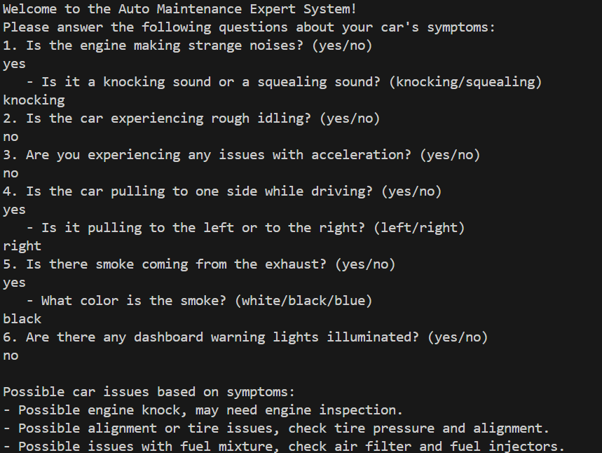

**Conclusion:** Implemented Expert System for 4-wheeler Automobile maintenance and successfully executed.